PRINT FIBONNACI PYRAMID PATTERN

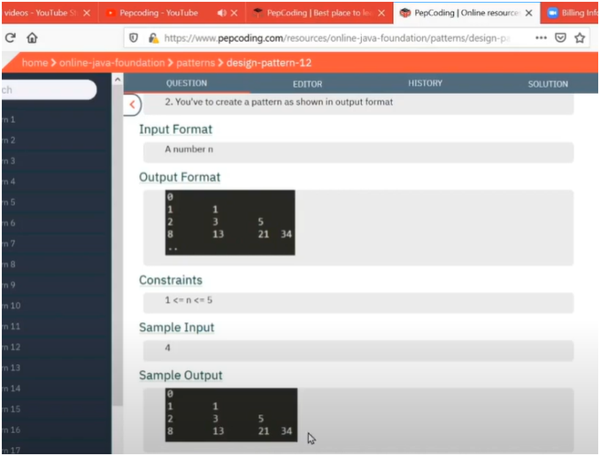

UNDERSTANDING:-

* + IF WE OBSERVE CLEARLY THE QUESTION IS ABOUT COMBINATION OF INCREASE RIGHT ANGLE TRIANGLE AND FIBONACCI SERIES LOGIC
  + HERE ON EACH ROW THERE IS A FIBONNACI SERIES PATTERN BASED ON CURRENT ROW NUMBER
    - MEANS IF CURRENT ROW NUMBER IS 1 THEN IT WILL PRINT FIRST FIBONNACI ELEMENT
    - IF CURRENT ROW NUMBER IS 2 THEN IT WILL PRINT NEXT TWO FIBONNACI ELEMENT
    - IF CURRENT ROW NUMBER IS 3 THEN IT WILL PRINT NEXT THREE FIBONNACI ELEMENT
  + AND FIBONNACI LOGIC MUST BE PRESENT INSIDE INNER LOOP THAT RUNS LOOP BASED ON CUURENT ROW

**ALGO:-**

**📌 What It Does:**

1. **Input:**
   * Takes total_rows as input (how many rows the triangle should have).
2. **Fibonacci Initialization:**
   * prev = 0, next = 1 → starting values of the Fibonacci sequence.
3. **Outer Loop (i from 1 to total_rows):**
   * Controls the number of rows.
4. **Inner Loop (j from 1 to i):**
   * Prints the Fibonacci numbers in each row.
   * Calculates the next Fibonacci number using:  
     total = prev + next,  
     then updates prev and next.